
The Global Consciousness Project
Roger D. Nelson, Director
http://noosphere.princeton.edu
rdnelson@princeton.edu (609) 924 4875

July 31, 2026

Stephen A. O’Connor Consulting

335 Court Street Suite 18

Brooklyn, NY 11231

Dear Stephen,

On the phone, you said you had mentioned the Global Consciousness Project (GCP) to some of your contacts, and their response was essentially, “Who are these guys?” You also said you could not access the links I had given you. I have put together an executive summary that I think addresses both issues. I hope this will provide you with what is needed to approach people who might appreciate the opportunity to help fund our project.
Over the past two years, the Global Consciousness Project has made major progress setting the stage for exploiting our 6.5-year accumulation of high-quality, continuously recorded random data. Thanks to seed funding from three donors, the data have been completely vetted and normalized, to facilitate access and guarantee reliability. In addition, we have completed a re-analysis that firmly establishes our original finding that high-visibility global events – things that deeply engage us – affect the GCP network.
This recent work gives us high confidence in the results, and takes the first steps toward a deeper understanding. We are at the beginning of a phase of data exploration that is designed to establish the nature of the anomalous effects we find in the data. Two fundamental questions with broad implications can be asked:
- What does it mean for physics and statistics that truly random numbers depart substantially from expectation and show structure where there should be none?
- What is the practical importance and the philosophical implication of anomalous departures from expectation that are correlated with matters of human interest?

The Project is summarized in the attached executive summary and enclosures. The last enclosure is a description of a budget that will allow us to proceed effectively. I will be grateful for an opportunity to talk with any potential donors about the project and its remarkable implications about the evolution of human consciousness.
Sincerely yours,
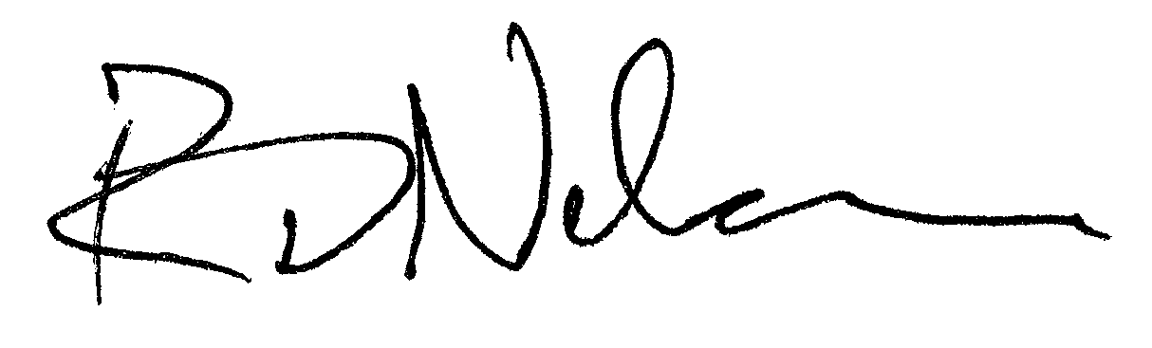

Roger D. Nelson
196 Valley Road, Princeton, NJ 08540, 609-924-4875

