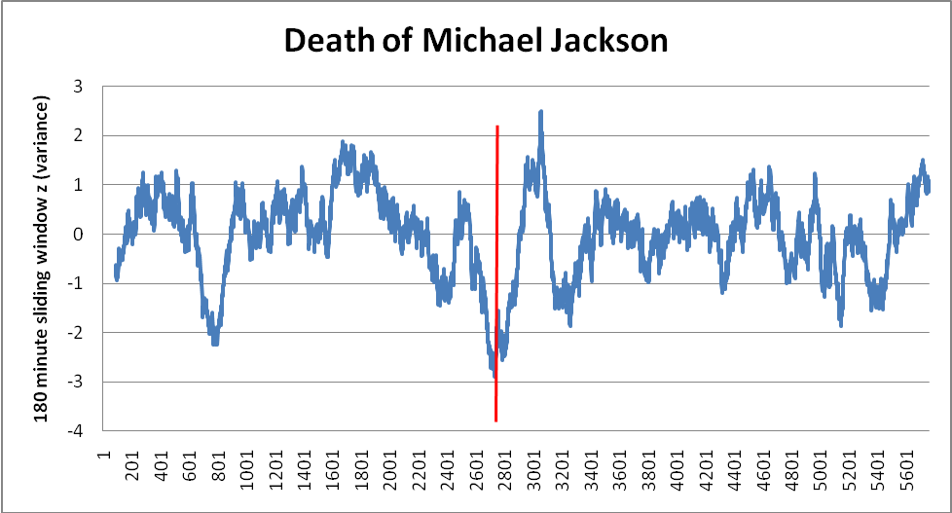
Here’s a purely exploratory analysis, based on daily GCP datasets (UT time) for June 24 – 27, 2009. The y axis is z scores, the x axis in minutes. I first calculated the empirical means and sd for each egg per day (with raw scores > 50 and < 150), then I generated a z score per egg per second, then summed the z scores and df to create a chi-squared score per second. Then I created a sliding window of these chi-squares 180 minutes in length (centered at the mid-point), and transformed the resulting chi-square back into a z score. The red line shows the time of the first announcement of MJ’s death, at 2:30 PM June 25. The deviation then rises over 5 sigma, peaking at about 7 PM. In this graph a negative z reflects lower than chance-expected variance, and positive indicates higher than chance-expected variance.
I think I did this right, but I’d appreciate an independent confirmation before posting this anywhere. I looked at sliding window sizes of 60, 90, 180 and 240 minutes in length. This is the width that shows the clearest outcome. Would this survive correction for multiple testing? Probably not.

