Notes for JSE Papers

- Introductory Remarks
- GCP Hypothesis
- GCP Network
  - Online Regs
  - Global Network Distribution
- Data Normalization
  - Standardization
  - Vetting
  - XOR’ing
  - Trial Statistics
- Formal Event Experiment
  - Introduction
  - Recipes
  - Event Characterization
    - Recipe Distribution
    - Period Distribution
  - Formal Results
    - Cumulative Z-score
    - Effect Size and Z-score Distribution
- Analysis of Formal Events
  - Event Selection for Analysis
  - Uniform Netvar
  - Uniform Covar
  - Uniform Devvar
  - Autocorrelations
  - Blocking
  - Parameter Correlations and Event Categories
    - Netvar vs. Covar
    - Online Regs
    - Big vs. Small Events
    - Impulse vs. Non-impulse
  - Slide Study
- Exploratory Analyses
  - Formal Events
    - New Year’s
    - Regular Meditations and Celebrations(Solstices, Earth Day’s etc.)
  - Non-formal Events
    - World Cup Games (112 events)
    - Strong Earthquakes (90)
    - Air Disasters (25)
    - Sunday/Friday Prayers (400)
  - Signal Averaged Epochs
    - Solar Day (3000)
    - Sidereal Day (3000)
    - Full/New Moons(100)

Formal Event Experiment

The GCP hypothesis postulates that data will deviate from expectation during global events but leaves open how to identify events and what kind statistical deviations occur during event periods. Accordingly, the formal experiment includes a range of event types, durations and statistical methods. The distribution of these parameters is indicated in the tables below and shows the complexity underlying the formal experiment.

The formal result is highly significant at Z = 4.6 on 215 events. If the hypothesis were simple (in the sense of uniquely specifying statistical tests on the data) this would be a convincing confirmation of global consciousness. However, because each event involves a number of unique decisions in deciding the prediction, the cumulative result is difficult to interpret and is less convincing for skeptics.

There is no problem with this and we shouldn’t expect the first experiment to resolve such a profound question. Indeed, the composite GCP hypothesis is precisely the way to begin an inquiry into global consciousness since more narrowly constructed approaches would have much less chance of seeing an effect.

An obvious question is whether the measured deviations are related to a subset of the parameters spanned by the formal experiment. Does the effect reside in a given category of event? In a particular statistic? Evidence for systematics in the experiment will guide hypothesis refinement and interpretation of the experiment while rendering the formal result more convincing. Thus, a thorough study of the formal result is a logical step to take before expanding the analysis to data periods not in the prediction registry.

A view and strategy for the study follows. First, looking for systematic deviations assumes that we can find some regularity to the effect and apply scientific methods to study it. It is good to keep this metaphysical orientation in mind; we are attempting to do science on the data. If this fails, we have a metaphysical/ontological quandary, as much as a scientific one. On the other hand, evidence of a systematic effect bolsters the claim that there is some “there” there.

Seeking a systematic effect also implies we expect some robustness to the result. That is, we can safely examine a representative subset of the experiment where expedient. This contrasts with the formal experiment where for methodological reasons we cannot exclude events or data unless there is a compelling reason. A strategy followed here is to homogenize the study somewhat when trying to sort out different contributions to the effect. Accordingly, the first 6 events (for which the network contained few regs and showed some stability problems) and 4 very long events are dropped from the analysis. Other small subsets of events are dropped when it is helpful to do so.

A second strategy is to study statistical properties of the data before investigating qualitative aspects of the events such as their type. The reason is that the power of the Z=4.6 formal result is limited and probing event types generally leads to low power tests on event subsets. Investigating different statistics, on the other hand, can benefit from use of the full event dataset. The approach is to let statistical studies inform a subsequent t investigation of event categories.

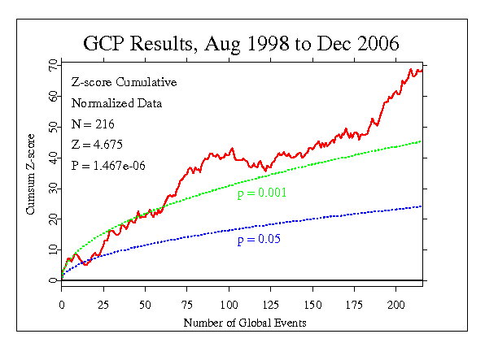

The study begins by asking what the nature of the deviations associated with events is, and whether there is evidence for characteristic time or distance scales in the data deviations.

Before addressing these issues, number of important conclusions can immediately be drawn from the formal event z-scores.
- The mean and variance of the event z-scores are 0.31 and 1.1, respectively. Because the cumulative Z is not due to outliers (trimmed means of the z-scores are flat for trimmings of 1% out to 20%, for example) we conclude that the effect is well distributed over events and that it is weak. Therefore, the robustness of the study (i.e., with respect to event groupings) should be legitimate. Furthermore, individual events cannot be expected to show significance.
- The formal experiment is dominated by two recipes: 1) the standard analysis at 1-sec resolution and 2) Reg-blocked Stouffer Z^2 at 15-min resolution. Extending these recipes over all events (where applicable) yields a cumulative Z of 3.7 for recipe 1 and -1.46 for recipe 2. We conclude that the effect manifests as positive deviation recipe 1 and is not present for recipe 2.
- It is shown below that recipe 1 corresponds to a positive Pearson correlation of inter-reg trial values. We conclude that the formal experiment indicates anomalous correlations in the GCP network. This is a wholly new effect that has not been previously measured in anomalies research. Recipe 2 is related to the variance of individual regs. We conclude that the experiment does not show evidence of deviations in the individual reg trial statistics.

- Recipe Distribution
75% of the 215 formal events use recipe 1, the standard analysis.

Recipe | Events
1 | 160
2 | 29
3 | 8
4 | 6
5 | 4
6 | 1
7 | 5
8 | 1
9 | 1

- Period Distribution
Event periods range from 1 minute to 9 days. However, only four events are longer than one day. The distribution parameters of the event periods are given in the table below. The figure shows the distribution of periods.

 | Events | % | Mean | StdDev
<= 1 day | 211 | 98 | 5 | 6.5
< 1 day | 195 | 91 | 3.5 | 3.8
< 8 hours | 178 | 83 | 2.5 | 2.3

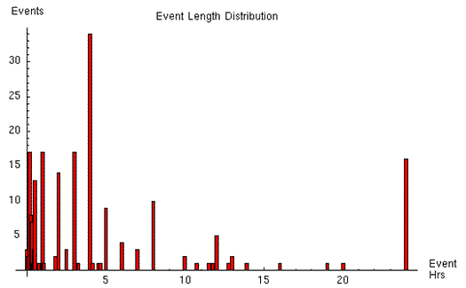
- Online Reg distribution

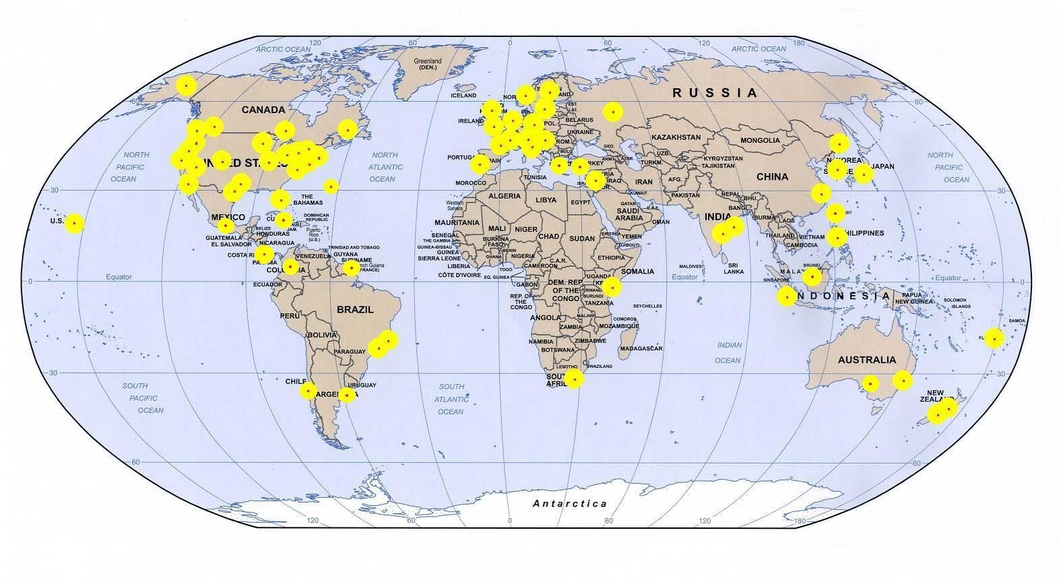

b. Statistics for Formal Events

The analysis begins by looking at the conclusions of the formal experiment. Recall that the data form a matrix of normalized trial scores, with one trial z-score/second/reg. The data studied here combine all matrix blocks corresponding to the times of the formal events. The formal experiment first blocks the data from an event and then calculates a block statistic, such as the Stouffer Z. Next, the recipe stipulates how the block statistics are combined to yield an event statistic. The figure below shows the procedure schematically.

Seconds
Regs | z | z | z | z | z | z | z | z | z | z | z | z | Z
Regs | z | z | z | z | z | z | z | z | z | z | z | z | Z
Regs | z | z | z | z | z | z | z | z | z | z | z | z | Z
Regs | z | z | z | z | z | z | z | z | z | z | z | z | Z
Blocking  Statistic | S |  |  |  |  | S | S | S | S | S | S | S | S
Event  Statistic | F(S) Event 1 |  |  |  |  | F(S) Event 2

The event-based experiment gives equal weight to each event statistic, regardless of the duration or the number of trials in the event period. The event-based weighting is useful for understanding the dependence on explicit event parameters, such as category, but complicates somewhat the interpretation of purely statistical factors. This complication can be avoided by treating the event data as a flat, single matrix and applying statistical operations uniformly without regard for event boundaries. Both event-weighted and flat matrix statistics will be presented for most analyses.

The study looks at the statistics of block statistics for a broad selection of blockings. As a first pass, the block statistics are taken as the block mean (as a Stouffer Z) and the (sample) variance of block trial scores. Since the trial data are nearly normal z-scores, these two block statistics can be taken as independent random variables (ref x) and thus functions of each will also yield independent quantities. We study the behavior of the block mean and variance by calculating significance of their first four moments (mean, variance, skewness and kurtosis).

Results are presented below for the individual trials with blocking from 1-second resolution up to T-seconds (where T goes up to 5 minutes) and blocking over time but not across regs (recipe 2 and the standard field-reg recipe). A capital “Z” is used to indicate a Stouffer Z of trial z-scores. Small case “z” is reserved for the trials.

Statistics studied:
First 4 moments for:
- No blocking
- Trial z-scores
- 1-second blocking (recipe 1)
- Stouffer Z
- Stouffer Z^2
- Sample variance
- T-second blocking
- Stouffer Z
- Stouffer Z^2
- Sample variance
- Reg blocking (recipe 2 and Field-Reg)
- Stouffer Z^2

Briefly, the results are stated here and the figures give more details.
Results:
- Statistics at the trial level are within expectation of the null hypothesis
- At 1-sec blocking: Netvar and Covar are significant and independent
  - the netvar = Var[Z] and Mean[Z^2] are equivalent.
  - Var[Z^2] is significant, but highly correlated with the Mean[Z^2].
  - Var[sample var] is significant.
  - Covar is highly correlated with Var[samp var].
- Netvar and covar imply Reg-Reg pair correlations
- At T-second blocking: Significance drops with block size
  - No significant autocorrelations beyond lag =1.
  - Possible autocorr for 1-sec Z at 1-sec lag: z-score = 1.97

Conclusions:
The significance of the netvar at 1-sec indicates the data contain reg-reg correlations. This is a new result in anomalies research. Some details of the statistics needs still to be worked out, but I believe this conclusion will hold.

The covar is an independent finding. It lends support to a claim of data anomalies (real correlations are contained in the data). It also suggests reg-reg correlations, similar to, but independent of the netvar.

Both the netvar and the covar are variance measures of the data. The covar is closely related to the variance of the sample variance. (It could be called the varvar)

There is no indication of anomalies in the base trial statistics.

Blockings beyond 1-sec rapidly diminish the significance of the covar and netvar. The connection to the autocorrelation is developed in detail below.

Blockings such as recipe 2 or “field-reg” blocking, which do not incorporate reg-reg pair correlations, do not show significance.

The independence of the netvar and covar allow them to be combined to a new (more powerful?) statistic (previously, the “dispersion statistic”). It also allows correlation tests between them. Generally, any systematic behavior found in one of these we expect naively to find in the other.

Correlation of the Netvar/Covar

This makes a very nice, but slightly involved story. See the section of entitled “Correlation of Netvar/Covar” in the pages below.

Event Slide of Netvar/Covar

This is also interesting, but involved. It pertains to time scales and has a connection with the netvar/covar correlation analysis. See similarly titled section below.

Trial Statistics

Descriptive trial statistics for 189 events are given in the table below. The event periods include 4,179,468 seconds (48.3 days or 1.6% of the database) and 207 million trials.

Trial Statistics – 189 Formal Events
 | Mean | Variance | Skewness | Kurtosis B[200,1/2]
Expectation | 0 | 1 | 0 | 2.99
Value | 0.000016 | 1.000027 | -0.000089 | 2.989949
Z-score | 0.23 | 0.27 | -0.26 | -0.15
Z-score  Event weighting | 0.50 | 0.88 | -0.39 | -0.05

We can conclude that there is no anomalous behavior in the distribution of Reg z-scores. The first three moments of the standardized trial scores are indistinguishable from N[0,1] or binomial B[200,1/2] statistics. The binomial character of the trial values is evident in the fourth moment, which has an expectation of 2.99, slightly different from the value of 3 for N[0.1]. The difference is highly significant: the measured kurtosis excess is 30 standard deviations relative to a N[0,1].

Figure The plot shows the first four moments of Reg trial values (mean, variance, skewness and kurtosis) accumulated as z-scores over events. The terminal cumulative deviations lie within 0.05 probability envelopes for all four statistics. The plotted event z-scores of trial moments weight trials according to the length of each event. Terminal values for equal trial weighting are indicated at the end of the traces.

Blocked Statistics
Mean:

Stouffer Z Statistics – 189 Formal Events
 | Mean | Variance | Skewness | Kurtosis
Expectation | 0 | 1 | 0 | 2.999[1-8]
Value | 0.000074 | 1.002374 | -0.0016 | 2.9995
Z-score | 0.15 | 3.43 | -0.89 | 0.20 N[0,1]
Z-score  Event weighting | 0.50 | 3.76 | -0.39 | -0.05

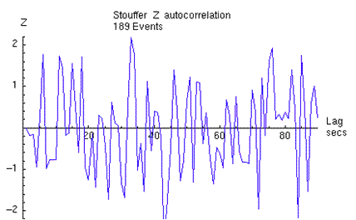

Mean Squared

Stouffer Z² Statistics – 189 Formal Events
 | Mean | Variance | Skewness | Kurtosis
Expectation | 1 | 2 | √8 | 15
Value | 1.002374 | 2.00901 | 2.83483 | 15.16226
Z-score | 3.42 | 2.49 | 0.86 | 1.27
Z-score  Event weighting | 3.75 | 3.02 | 0.76 | 0.93

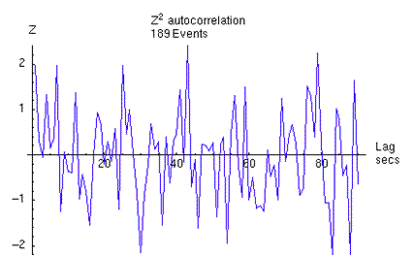

Sample Variance
Let s² be the unbiased sample variance and n the number of samples. The s² cannot easily be projected onto a uniform distribution independent of reg number (like converting the mean to a Stouffer Z). The statistics for event-weighting are determined from Monte Carlo estimates. The flat-matrix Z-scores are estimated from that by un-weighting according to event length. The sample variance mean and variance are shown in the plots that follow. It is also not easy to estimate the autocorrelation directly from the sample variance. However, the covar statistics are very close to the sample variance and its autocorrelation is shown further below.

Sample Variance Statistics – 189 Formal Events
 | Mean | Variance | Skewness | Kurtosis
Expectation | N | Var [s² ] | - | -
Value | - | - | - | -
Z-score | -0.09 | 2.43 | -0.33 | -.55
Z-score  Event weighting | 0.37 | 2.90 | 0.39 | 0.11

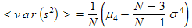

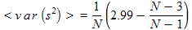

Covar Statistic: very similar to Sample Variance…

Covar Statistics – 189 Formal Events
 | Mean | Variance | Skewness | Kurtosis
Expectation | 0 | 1 | - | -
Value
Z-score | 2.67 | Need to complete Monte Carlo and re sampling analyses for these stats.
Z-score  Event weighting | 2.95

7. Analysis of Formal Events

The formal event analysis looks at statistics applied homogeneously to the events. In essence, the prediction registry is used to select a subset of the data for analysis. This is suggested by the formal event experiment. The analysis investigates these data in detail. Are there statistics which show reliable deviations across events? Which ones and how are they related? Do they correlate? Etc.
Some selection is needed in order to do this. Rejected formal predictions are excluded. It doesn’t matter too much how the choice in made, as long as there is a good representation of the events and a reasonable number of them.

The large range of event period lengths complicates some analyses. I drop 5 events very long events for this reason. The New Year’s predictions are also not amenable to general analysis. Additionally, I drop events before Oct. 1998, when the network was unstable. A second option is to drop events with few regs online which puts the cutoff near Aug. 1999 when the network stably approached 20 online regs. For the moment, I work mainly with two sets: 189 events after Oct. 1998; the same set augmented with 8 NYr’s events.

Reflecting a bit, one will inevitably wonder how the important New Year’s events might change the analysis, particularly – as we will see – since important events seem to have larger effect sizes. I’ve thus decided to include them in a second set as 23 hr periods around Greenwich midnight. This is in keeping with numerous events which use day long periods to bracket a diffuse event. The time period begins an hour before New Zealand celebrates and ends and hour after California. Other choices could be made. This one seems consistent with the spirit of the prediction registry.

e. Blocking

We need to select a blocking for any analysis, so it is important to determine experimentally what blocking is appropriate. There is a close connection between the blocking and autocorrelations. Previously, we have set a blocking starting from the first second of a dataset and compared statistics for different block sizes. However, since there are b-1 ways to block data into blocks of size b, this provides a noisy estimate of the blocking dependence. A better approach, which avoids brute force calculation of all blockings is to use the autocorrelation to estimate the blocking dependence of a statistic.

The short answer is that the Stouffer Z² blocking depends the Stouffer Z autocorrelation. Since the autocorrelation is not significant, we expect the optimal blocking to be at 1-second resolution . The figure shows the autocorrelation out to a lag of 90 seconds.

The procedure for estimating the blocking from the autocorrelation, along with some results, is sketched below:

Consider the netvar expressed as a sum of Stouffer Z² at 1-second resolution. The sum is a chi-squared statistic with T degrees of freedom, for a sample period of T seconds. This can be generalized to blockings of the Stouffer Z at B-second resolution. Below, Z_{t} is the Stouffer Z at 1-second resolution at a time t and Z_{B} is the Stouffer Z for a block.

The blocked chi-squared statistic over a sample S of T seconds is

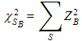
The blocked chi-squared has T/B degrees of freedom. In terms of 1-second Z’s this becomes

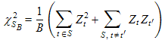
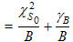
is the usual chi-squared term at 1-second resolution. The expression shows that the value of decreases as 1/BlockSize and contains a term related to the autocorrelation of Z. A strong positive autocorrelation can thus lead to increased statistical significance for blockings greater than 1. Noting that the autocorrelation of Z_{t} at lag L is a standard normal variable proportional to <Z_{t}Z_{t-L}> allows the following approximation:

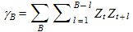
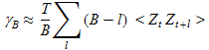
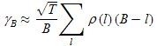

Here, ρ(L) is the normalized autocorrelation at lag L and T is the sample size in seconds. As usual, it is useful to express statistical quantities as z-scores. For B<< T, the equivalent z-score as a function of block size becomes:

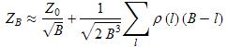

The blocking analysis for the 189 event dataset is shown in the figure below. The event data are extracted and concatenated into a single vector of 4,179,468 Stouffer Z-scores. The red trace shows z-score of the summed Z² ‘s as a function of blocking for a specific blocking starting at second t=1. The blue curve shows the expectation of blocking behavior for zero autocorrelation. The estimation of the blocking values over all blockings, as described above, is shown in the gray trace. It is clear from the analysis that autocorrelations are not contributing to the blocked statistic and that blockings B>1 merely add noise the chi-squared statistic, depressing its statistical significance.

The validity of the approximation using autocorrelations can be tested by calculating the blocking results over all blocking configurations. This is shown for a selection of block lengths in the plot below. The approximation is extremely good for small blockings and slowly deviates from the exact calculation as B increases.
Figure. The plot shows the close correspondence between the autocorrelation approximation to blocking statistics (gray trace) and an exact calculation of the blocked statistic averaged over all realizations of a given blocking (diamonds).
It is interesting to look at the blocking for the augmented dataset including New Year’s events. The 8 events add 16% to the data vector. In this case, the raw blocking appears to show a contribution from the autocorrelation. However, the blocking average estimated from the autocorrelation clearly shows that the 1-second blocking is still favored.

Estimated errors from the autocorrelation are shown in the probability envelope in the following figure. It shows that the 1-sigma deviation of the blocking is within expectation of the zero autocorrelation result, confirming the choice of 1-second resolution as the preferred netvar blocking.

The blocking analysis for the Covar is a bit more complicated and will be added later.

Netvar/Covar Correlations

The netvar and covar are identified as significant statistics over events. If the significances are due to global consciousness, we expect correlations to emerge between these two statistics. A comparison of the statistics per event gives a Pearson correlation z-score of 0.75. A Kendall Rank correlation gives a z-score of 0.6. These are weak, but positive and a closer look is needed to assess the correlations. Here the linear (Pearson) correlation is investigated.

The event-based netvar/covar correlation sited above is the correlation of 189 event z-scores between the two statistics. As usual, each event z-score is determined by summing the 1-sec netvars(covars) over the event and converting the cumulative deviation to a z-score. Thus the correlation taken at the event level sums the data irregularly over many different lengths, according to the separate event durations.

A simpler approach is to flatten the netvars(covars) into single vectors and block the vectors uniformly. The blocks are then summed and converted to z-scores, as for the events, and the z-scores are then used to calculate a correlation. (Note that the netvar/covar is still blocked at 1-sec; it is the blocking for the summation of netvars(covars) which is being investigated.)

A brief reflection shows that this procedure lends insight into the time scale of the effect. We have seen that the statistics blocked at 1-sec resolution have the greatest effect size. The implication is that there is a time scale which operates at 1 second or less. On the other hand, there must be a second, longer time scale associated with the events. Presumably, this involves the ‘attention span’ of global consciousness, the persistence time of the effect for a given event. Events generally last a few hours and we can assume that the statistical significance is distributed across this time period since there are no outliers at the 1-second level. That is, the effect is not due to a few highly anomalous seconds. Nevertheless, we do not expect that the reg-reg correlations underlying the significance are perfectly evenly distributed over all events and all times. It may be, for example, that the correlations typically persist for a few hours. In that case formal event specifications of longer duration would contain periods of both correlated and uncorrelated data. These different scenarios lead to predictions for structure in the netvar/covar correlation as a function of blocking. For a perfectly evenly distributed effect, the correlation is independent of the blocking. A persistent correlation with a characteristic time scale gives rise to the following blocking behavior. At short block sizes (relative to the characteristic time) the netvar/covar correlation is near zero. The correlation grows rapidly as blocking increases to the characteristic time scale. For longer blockings the correlation coefficient decays slowly to a non-zero value.

A blocking study of the netvar/covar correlation coefficient shows a marginally significant z-score of roughly 2.0 over a range of 1-5 hours. The shape of the blocking trace is consistent with simulations using persistence times in this range. See plots below.
Figure. Netvar/covar correlation coefficient (as a z-score) over event data as a function of block (bin) size. The gray trace is the correlation from a pseudo random set of netvar and covar values. The single value for data blocked into formal event lengths is shown in green. The blue trace (“trim”) excludes data from 24-hr events. For the red and blue traces: note the sharp rise from zero to z=2 for blockings less than 1 hour, followed by a gradual decline to an intermediate value around z=1.

The signal to noise of the correlation blocking study can be improved by averaging all possible realizations at each block length (similar to the blocking analysis of the netvar and covar statistics). This improves the power of the correlation statistic and allows for several secondary analyses. Two are shown below: 1)Aligning impulse events to the actual impulse start times increases the correlation. 2) The correlation is pronounced for “big” events and marginal or zero for “small” events. Similar results were found for the netvar and covar statistics. The correlation measure thus gives a third, independent result supporting an increased effect size for events involving large populations.
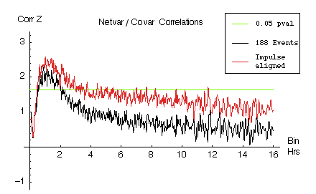
Figure. Netvar/Covar correlation for flattened event data as a function of blocking. The traces compare correlation for formal event data and data with impulse events aligned to actual impulse times. The alignment effects the data selection of 50 impulse events. The 15 early events in 1998 with small numbers of online regs are excluded for comparative purposes.
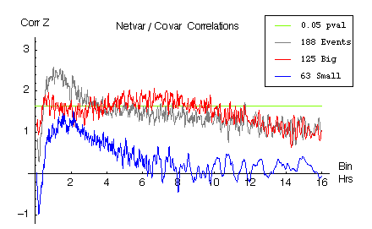
Figure. Netvar/Covar correlation as a function of blocking for “big” and “small” event sets on impulse aligned events.

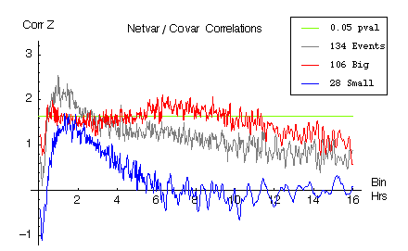
Figure. Netvar/Covar correlation as a function of blocking for reduced “big” and “small” event sets on impulse aligned events. Events shorter than two hours have been excluded. The exclusion reduces the data vectors by only a few percent, and indicates that the marginal correlation for the small events is not due to a preponderance of short event durations in the small event set. The average event length of both the small and big event sets exceeds 8 hours.

Figure. Red trace: A finer sampling of the correlation coefficient as a function of block size. Note the sharp rise from zero for blocks less than ½ hour, a persistence for blocks of 2-6 hours, followed by a decline to lower significance at 10 – 15 hours. Blue trace: Simulation of 600 13-hr events with netvar/covar effect size of 0.3 and a randomly distributed persistence time of 2 – 6 hours. The main point of the plot is that the red experimental trace shows definite structure and indicates something special about the 2 – 6 hour time scale. There is a sharp rise from zero to the plateau value, followed by a slow decay to intermediate values.

Figure. The plot shows the distribution for netvar/covar correlation statistics for blockings using uncorrelated pseudo random data consistent with the null hypothesis. Each gray point locates the mean and variance of the blocking values for a simulated event data set. The red point is the value for the GCP data set. The red point lies marginally at the edge of the null distribution. This plot is complicated and probably needs more extensive explication to be understandable! It is another way to show that the netvar/covar correlation deviation from the null hypothesis is marginally significant.

Big vs Small Events

The event set is sorted into two groups corresponding to big and small participatory populations. This is based on an intuitive guess of the impact of the event on a global scale. The qualitative sorting give 125 big events (including 7 New Year's events taken as 23 hour periods starting in New Zealand and ending in California) and 66 small events. The netvar and covar statistics are compared for these groups.

Statistic  \\ Group | Netvar |  | Covar |  | Netvar + Covar |  | Netvar/Covar Correlation
weighting | event | time | event | time | event | time | 1-hour | 6-hour
Big | 3.97 | 3.68 | 3.19 | 2.74 | 5.06 | 4.56 | 1.6 | 1.8
Small | 1.01 | 0.85 | 0.77 | 0.97 | 1.31 | 1.24 | 1.4 | 0.1
Difference  pvalue | 0.09 |  | 0.14 |  | 0.04 |  | -

Event Slide of Netvar/Covar
Another way to look for time scales of the event duration is to study the event slide analysis. The slide analysis calculates a cumulative z-score for events as a function of a time offset. This is equivalent to “sliding” event data windows over the formal event times. The slide analysis tests whether the formal event lengths accurately capture the persistence of reg-reg correlations as measured by the netvar and covar statistics.

A variation on the event slide is to choose a fixed window length for each event. This gives the convolution of the window with the persistent correlations (if any) in the events. The fixed-window slide can be set so that windows align either to the formal start time of events or to the formal end times. The former is a measure of correlation persistence during and preceding the events. The later is a measure of correlation persistence during the event and extending beyond the formal end times.

The first figure below shows the expected slide behavior for 900 events of identical length, L, for a selection of L. This is equivalent to the convolution of a window with a box signal and gives a triangular response of base 2L. It shows that the slide value is a maximum when the window is aligned to the event, and decreases linearly as the window slides off the event. An experimental slide trace peaked near zero indicates that the formal prediction times roughly correspond to the actual correlation persistence in the data.

The following plot shows an important verification of the independence of the netvar and covar. We have verified by random sampling from the full database that the netvar and covar have negligible correlation outside of global events. The same result is confirmed by simulations using pseudo random data. Note that this only tests the expected correlation when the random samples have zero mean. In the case of the netvar/covar correlation over the event data set, we know that the netvar and covar both have a significantly non-zero mean. Therefore we need also to verify the conditional case that the netvar and covar have vanishing correlation, given that one of the statistics deviates from its expectation. Equivalently, we want to verify that the covar has zero expectation given that the netvar expectation is non-zero.

A simulation to verify this uses the GCP database from Jan. 1999 through Aug. 2006. A set of 2500 3-hour “events” is drawn randomly from the database such that the mean netvar value is 0.31 (i.e., the value of the formal experiment). The covar data from the same period is retained and a slide trace is calculated for each. The result shown in the plot below is that the netvar exhibits the expected behavior of a triangular peak at zero slide offset, while the covar slide is within expectation of the null hypothesis. This indicates that the two statistics are independent since their conditional probability distribution P[covar | netvar] is the same as P[covar]. A bit more work needs to be done on this to make it solid. It will provide a firm basis for claiming that the netvar and covar correlation is independent evidence against the null hypothesis.

Very quickly now: Below is a potentially important new result. The data set is from 119 “big” events, a representative set. The slide is for a fixed window aligned to the event end times. It shows that there is a post-event swing of opposite sign in both the netvar and covar. It is marginally significant and seen in both statistics.

The mean and standard deviation of the big events durations are 6.9 and 7.2 hours, respectively. The median duration is 4 hours.
Figure: Blue trace: netvar. Red trace: covar. Black: dispersion stat = netvar + covar

Here’s what the dispersion stat slide looks like for windows aligned to the event start times and the event end times.

Chi Square Excess
Any theory of global consciousness eventually will need to provide a model of the data at the device level. Our evidence for global consciousness rests on deviations from expectation in several key correlation statistics. Although we are confident that the significance is not due to outliers, we have not looked at how the statistics deviate in any detail. Because there are several deviating statistics, it will be possible to constrain (triangulate) the behavior of the underlying netvar and covar statistics, and eventually the trial distributions of the regs, and so guide modeling of the effect.

A full study is beyond the scope of the paper, but an indication of the key points can be presented rather easily. The preliminary results on the deviation distributions of our statistics not only provide more information for the reader, but also serve to draw attention to this important direction for future analyses.
A starting point is to determine how the cumulating excess in the netvar and covar results are distributed. Can we model the deviations as a simple shift in the mean of these statistics? Does the excess reside in the tails or near the distribution center? Does the excess distribute symmetrically? Etc.

The plot below shows the netvar excess at the 1-second level for the events. The netvar data are binned by their chi-square values and the deviations from expectation for the bins are plotted. In the plot, the red trace is the cumulative deviation of the values (blue trace; the axes give the z-score equivalent of chi-square: zero on the horizontal axis corresponds to a chi-square of 1, etc. The chi-square excess – totaling about 9,000 for these data – is expressed as an z-score on the vertical axis). For example, the chi-square bin for value 1 counts the difference between the actual and expected number of netvar data with value 1. Suppose, at value chisq=1, there are 10 fewer than expected out of the 4 million data-seconds in the events. Then the bin count is -10, since there are 10 fewer data with value = 1 than expected. Similarly, if there are 100 more data with chisqr= 0.1, the 0.1 bin has a value -90, since there is an excess of data with values 0.1,and 0.1 is -0.9 less than the mean chi-square expectation of 1.

To summarize, the plot shows how the excess accumulates as a function of the netvar value. At a glance one sees that most of the excess is due to netvar data (aka Stouffer Z^2) in the range of z-score 1.5 to 2.8 (chi-square range of +3 to +8). This implies that the effect resides in the positive tail of the netvar distribution, and at the same time is not due to outliers. It also implies that less than 5% of the data are “deviating” which may help explain why we only see the effect at statistics with 1-second resolution.

Generally, we're at a point where any new information we find immediately impacts and folds into what we already know. This is when it gets fun.

Some more work is needed to unpack this further, but it's easy to see that we can provided some essential information about the deviations. A parallel analysis for the covar will give a nice starting point for modeling the effect.

Here are some unrelated plots that show descriptive statistics of the raw trial z-scores cumulated over events and grouped into a single vector (single z-score points plotted after the cumdev traces). I look at the first four moments (Mean, Variance, Skewness and Kurtosis). The analysis shows that there is nothing unusual in the event data at the trial level. This is a lead-in to looking at statistics blocked at one second, like the netvar and covar. Those statistics include correlations between regs and do show statistical significance. Note: the Kurtosis is based on Binomial[200, ½] statistics. The others are based on Normal[0,1]. The Kurtosis z-score goes to a Z of 5 or 6 if it is based on normal statistics.

