THE FUJI DECLARATION
AWAKENING THE DIVINE SPARK IN THE SPIRIT OF HUMANITY
For a Civilization of Oneness with Diversity on Planet Earth

A new phase in the evolution of human civilization is on the horizon. With deepening states of crisis bringing unrest to all parts of the world, there is a growing need for change in our ways of thinking and acting. We now have the choice of either spiraling into deepening peril, or breaking through to a world of dignity and wellbeing for all.

Throughout its history, humanity has been guided primarily by a material consciousness. Fearing scarcity, we have continued to pursue material gain beyond necessity, taking from others and depleting the Earth’s natural resources. If our aspirations continue to focus only on what is material and finite, our world will face inevitable destruction.

What is our true nature?

In order to make more enlightened choices and change the course of our history, we need to return to the basic question concerning human life. Each and every one of us must ask, “What is our true nature?” and seek a meaningful and responsible answer.

The great spiritual traditions of the world have always been telling us that, at its root, human life is inextricably linked to its universal source. Today, the latest advances in the physical and life sciences reaffirm this perennial insight. When we rediscover our connections to nature and the cosmos, we can re-align our life with the universal movement toward oneness and harmony in and through diversity. We can restore the divine spark in the human spirit and bring forth our innate love, compassion, wisdom, and joy to live a flourishing life. The time has come for every one of us to awaken the divine spark that resides in our heart.

What is the purpose of our existence?

We have been born at a critical juncture in history, in a world in transition, where it is possible to guide the advancement of humankind toward peace on Earth. Living peace and enabling peace to prevail on Earth is the ultimate purpose for all of us. We can and must embrace it in every sphere of our existence.

By living consciously and responsibly, we can draw upon our inherent freedom and power to shape our destiny and the destiny of humankind. Our task is to collaboratively create a world of dignity and compassion that unfolds the full potential of the human spirit—a world in which every individual gives expression to his or her highest self, in service to the human family and the whole web of life on the planet.

Toward a new civilization

It is imperative to bring together individuals from diverse fields—scientists, artists, politicians, religious and business leaders, and others—to create a solid multidimensional foundation for catalyzing a timely shift in the course of history. The time has come for all people to become courageous pioneers—to venture beyond their personal, cultural, and national interests and beyond the boundaries of their discipline, and to come together in wisdom, spirit and intention for the benefit of all people in the human family. By so doing, we can overcome the hold of obsolete ideas and outdated behaviors in today’s unsustainable world and design a more harmonious and flourishing civilization for the coming generations.

The paradigm of the new civilization

The paradigm of the new civilization is a culture of oneness with respect for diversity. Just as the myriad cells and diverse organs of our body are interconnected by their oneness and work together in harmony for the purpose of sustaining our life, so each and every living thing is an intrinsic part of the larger symphony of life on this planet. With the conscious recognition that we are all a part of a living universe consisting of great diversity yet embracing unity, we will co-evolve with one another and with nature through a network of constructive and coherent relationships.

We, as individuals responsible for our and our children’s future, hereby declare that:

—We affirm the divine spark in the heart and mind of every human being and intend to live by its light in every sphere of our existence.
—We commit ourselves to fulfilling our shared mission of creating lasting peace on Earth through our ways of living and acting.
—We intend to live and act so as to enhance the quality of life and the well-being of all forms of life on the planet, recognizing that all living things in all their diversity are interconnected and are one.
—We continually and consistently strive to free the human spirit for deep creativity, and to nurture the necessary transformation to forge a new paradigm in all spheres of human activity, including economics, science, medicine, politics, business, education, religion, the arts, communications and the media.
—We shall make it our mission to design, communicate and implement a more spiritual and harmonious civilization—a civilization that enables humankind to realize its inherent potential and advance to the next stage of its material, spiritual, and cultural evolution.

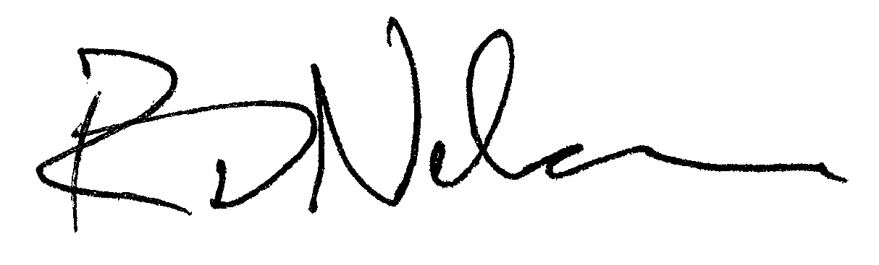
ENDORSED BY:

__________________________________

Name: Roger Nelson, Director, Global Consciousness Project

