Introduction

The Global Consciousness Project has been running continuously since August 4, 1998. After six years of examining the global consciousness hypothesis, a highly significant result of 4 standard deviations has obtained. This success has encouraged us to undertake an extended analysis of the project's results and methods. Our goals are to document the analytical and methodological basis of the main result, as well as to guide the project towards framing hypotheses and experiments that can help to elucidate the meaning behind these measurements.
In order to move forward, it will be useful, even essential, to have help from people with scientific and technical backgrounds. However, the GCP results are complex and some familiarization is required before one can approach the data intelligently. Thus, a further goal of this analysis is to reduce the effort needed to contribute to the project by presenting a technical introduction to the data and the experimental results.
We would like to arrive at a point where a number of specific hypotheses can be proposed and tested against the database. Because we know nothing(!) about mechanisms or models that might explain the GCP result, it seems premature to examine the database outright for patterns or correlations that might point to anomalous results. Instead we begin by looking more closely at the result in hand. By studying the event-based experiment we hope to provide guidance for a subsequent, thorough look at the database. That will set the ground to test the data for correlations with independent parameters based on societal or environmental factors. But first, we need to decide with which statistics and tests it will be best to work.
The analysis of the event-based experiment is presented briefly below. It should give you a good sense for what has been accomplished so far, where further work is needed and where you might (should you be inclined...) contribute.
Key elements of the project are summarized first. These points are probably familiar. Further details can be found elsewhere on the GCP site.

The GCP hypothesis

The formal hypothesis of the event-based experiment is very broad. It posits that engaging global events will correlate with variance deviations in the data. The identification criteria of global events and the algorithms used for calculating event statistics are not prescribed by the hypothesis and vary from event to event. This latitude of choice is the one reason why the experiment is complicated to analyse.

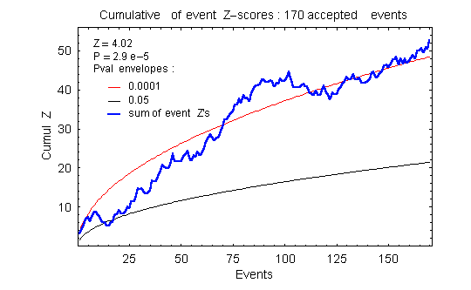
Figure: The cumulative deviation (cumdev) of event Z-scores for 170 formally accepted events through September 7, 2004. Standard normal trial scores were used for all event calculations. The cumdev terminal value has a Z-score of Z = 4.02 (pval = 0.00003).

The GCP Data

Overview
A few statistics on the database are listed in the table.

GCP Data: Aug. 4, 1998 – Sept. 8, 2004
Total days | 2224.6
Total trials | 7.64E+9
Total events | 183
Total accepted events | 170
Z-score of accepted global events | 4.02
Online reg-days | 84772
Average regs online/day | 38.1
Current regs online | 60-65
Total non-null trials | 6.85E+9
Total nulls | 7.93E+8

(Note: the raw data files list times and values of reg output. This doesn't constitute a database in the strict sense of the term. We use database in a looser sense, to refer to all the GCP data through Sept. 8, 2004)

Regs
The data are produced by three different makes of electronic random number generators (regs): Pear, Mindsong and Orion. All data trials are XOR'd sums of 200 truly random bits. The trialsums are collected once a second at each host. The Pear and Mindsong regs produce about 12 trials per second and the Orions about 39 (thus 95% of the reg output is not collected).
Regs are added to the network over time, and the data represent an evolving set of devices and geographical nodes. The network started with 4 regs and currently has about 65 in operation. This contributes to the complexity of some analyses.

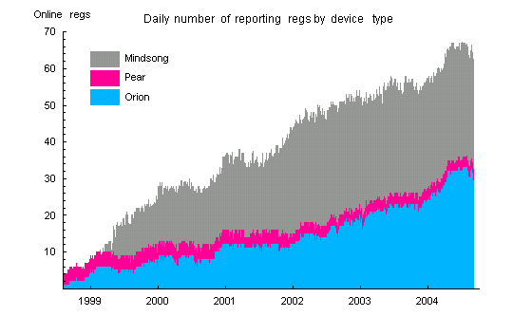
Figure: Number of reporting regs in the GCP network by device type.

XOR
Ideally, trials distribute like binomial[200, 0.5] (mean 100, variance 50). For these real-life devices, an XOR bitmask compensates mean biases of the regs. The XOR'd data has very good, stable means. XORing does more than correct mean bias. For example, XORing a binomial[N,p] will transform it to a binomial[N, 0.5], so the variance is transformed as well.
The Pear and Orion regs use a “01” bitmask and the Mindsong uses a 560-bit mask (the Mindsong mask is the string of all possible 8-bit combinations of 4 ”0”'s and 4 ”1”'s.

Variance bias
After XOR'ing, the trial variances remain biased. The biases are small (about 1 part in 10,000) and appear stable on long timescales (we don’t have any statistical measure of the stability at this time). They are corrected by standardization of the trialsums to standard normal variables (z-scores). Mindsong regs tend to have positive biases. This gives a net positive variance bias to the data. Since the GCP hypothesis explicitly looks for a positive variance bias, these are important, albeit small, corrections. The variance biases tell us that the raw, unXOR'd trials cannot be modelled as a simple binomial with shifted bit probability.
The sensitivity of analyses to variance bias depends on the statistic calculated. Two typical calculations are the trial variance and the variance of the trial means (for a given time blocking). That is, Var(z) and Var(Z)==Var(Sum(z)), where z are the reg trials and the sum is over all regs for each second. We sometimes refer to these as the device and network variances, respectively. (Note: when using standardized trial z-scores, there is little difference between variances calculated with respect to theoretical or sample means; theoretical and sample variances will be distinguished where necessary).

Out-of-bound trials
The regs occasionally produce improbable trial values. This is usually associated with intermittent hardware problems. These trials are removed before analysis. All trialsums that deviate by 45 or more from the theoretical mean of 100 are removed and replaced by nulls. This cutoff does not distort the database by excluding valid trials. The expected erroneous exclusion of valid trails is 3 or less at a 95% confidence level (in a dataset of 7 billion trials). See the data preparation page for more details.

Rotten Eggs
Once out-of-bound trials are removed, the mean and variance of each reg are checked for stability. Sections of reg data that do not pass stability criteria are masked and excluded from analysis. Data from these “rotten eggs” are usually very obvious. Nevertheless, there are cases where excluding data is a judgment call. The current criteria impose a limit that will, on average, exclude 0.02% of valid data (an hour or two of data per year). See the data preparation page.

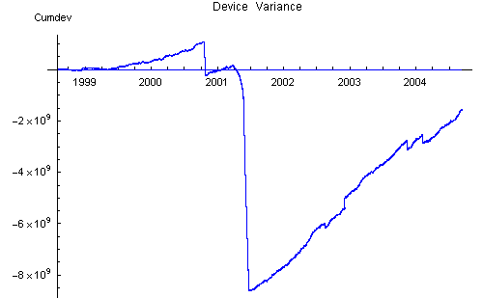

Figure: Device variance cumulative deviation. The variance was calculated after removing out-of-bounds trials, but before removal of rotten egg data and before normalization. The discrete jumps are due to bad (“rotten”) reg data. The large positive slope between jumps is due to variance bias of the individual regs. This bias is primarily coming from the Mindsong regs.

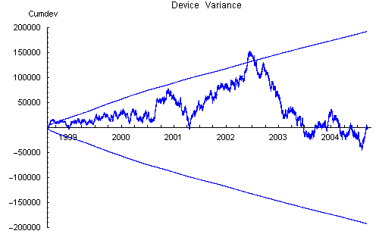
Figure: Device variance after removal of rotten egg data and normalization of the reg trials to standard normal variables. The envelope shows the 0.05 probability values for chi-squared statistics. The envelopes appear distorted because the variance is plotted versus time instead of the chi-square degrees of freedom.

Nulls
It is fairly common that egg nodes send null trials. Nulls may persist for long times, as when a host site goes down, or may appear intermittently. Nulls do not cause problems for calculations on the data, but they can add to the inherent variability of some statistics. Currently, about 10% of the trials are nulls.

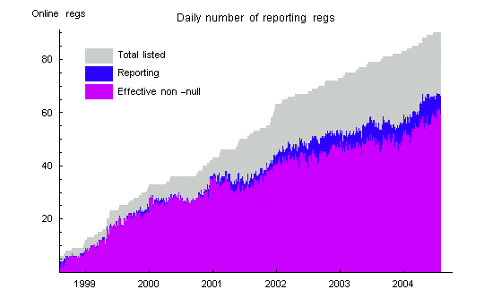
Figure: The plot shows the presence of null trials in the data. The regs reporting is the number of reg hosts that send data packets on a given day. An indication of the amount of null trials is given by the difference of reporting regs and the effective non-null reg count which counts a reg as non-null if it has at least one non-null trial for a minute. The count of non-null minutes is averaged per reg for the day. The gray shading shows the cumulative total of regs that have been listed in the network. The number of listed regs is greater than the number of reporting regs because regs are removed when a host is de-commissioned and removed from the network.

Bad network days
On a few days, the network produced faulty or incomplete data. These occurred during the first weeks after the GCP began operation and during hacker attack in August 2001. The days August 11, 25, 31 and September 6 have less than 86400 seconds of data. These days are retained in the database. For the days August 5-8, inclusive, the data consists mostly of nulls for all regs. These days have been removed from the standardized data.

The Event-based Experiment

The event-based experiment measures statistical deviations associated with global events and combines these into a cumulative, or aggregate, result. Basic parameters and terminology are defined below.
Protocol
The experimental protocol is to identify a global event and a statistical measure to be calculated. This constitutes an event prediction. Predictions may proposed to the project director by GCP collaborators or other interested persons. Accepted predictions are entered into a formal prediction registry before data is accessed from the database archive.
Event selection
In keeping with the exploratory nature of the experiment, there is not a unique criterion for accepting proposals as global events. Event selection is subjective and is guided by experience and consultation. Most events are considered global because they involve the attention or activity of many people around the world and figure prominently in news reports. Thus, a local event such as a natural disaster can be considered global if it gains global attention. Other criteria are used. A few astrological events are accepted because of their non-local (therefore, global) character. Certain prayers and meditations that involve relatively modest numbers of people are accepted because there is a global intention such as world peace. A look at the experimental result as a function of event category is presented in the analysis section.
It is not a contradiction to maintain that the experiment is both open-ended and rigorous, but it is important to state where the rigor lies. Once a prediction is made, the analysis is rigorous and unambiguous. Event selection, prediction definition and the ongoing nature of the experiment are not rigorous in this sense. Thus, the experiment should not be viewed as constructing a hypothesis to test against a significance level, as is done for classical hypothesis testing. This does not, of course, rule out judging that the 4-sigma result is highly significant, which is a matter of assessment, and not a report of a test result. It is important to highlight this aspect of the experimental methodology.
Since most events correspond to newsworthy happenings, the frequency of events over time varies. Nevertheless, the experiments adds a fairly regular number of events per year (about 25-30).

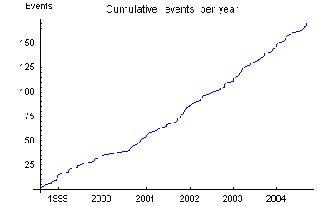
Figure: The cumulative number of accepted global events per time.

Predictions
An accepted prediction specifies an examination period for the data associated with the event, and a statistic to be calculated. The statistic is determined by a recipe which includes a blocking for the data. A weighting is determined for combining event statistics into the cumulative experimental result.
Examination Periods
The length of an examination period reflects a guess of a time for which an event will correlate with the data. Periods vary from 1 minute to many days, but about 75% of the events have examination periods of 4 hours or less. Most predictions specify contiguous data blocks, but some multi-period events are accepted. An example is event 48 which selects an hour-long ceremony repeated 4 times during a single day. In order to assure statistical independence, examination periods may not overlap. If a long event overlaps a short one, the overlap period may be removed for the long event and assigned to the short one. This creates separated periods for the long event and is termed a fractioned event. Details of the distribution of examination periods are given in the tables and figure below.

GCP Events: Aug. 4, 1998 – Sept. 8, 2004
Shortest event | 1 minute
Longest event | 9.27 days
Average event length (170) | 8.4 hrs
Median event length (170) | 2.5 hrs
Average length, events < 1 day (156) | 2.8 hrs
Median length, events <1 day (156) | 2 hrs
Multi-period events | 15
Fractioned events | 3

Period Length | Number of Events | Period Length | Number of Events
1 minutes | 2 | 4.15 hours | 1
4.8 | 1 | 4.17 | 1
5 | 2 | 4.63 | 1
6 | 1 | 5 | 4
10 | 13** | 6 | 3
15 | 6 | 7 | 2
20 | 3 | 8 | 5
24 | 1 | 10 | 2
25 | 2 | 10.75 | 1
30 | 12 | 11.5 | 1
35 | 1 | 12 | 1
40 | 2 | 13 | 1
45 | 1 | 16 | 1
60 (1 hour) | 15 | 16.47 | 1
62 | 2 | 21 | 1
65 | 1 | 23 | 1
1.5 hours | 1 | 23.5 | 1
1.8 | 2 | 24 | 9
2 | 12 | 4 days | 1
2.17 | 1 | 4.49 | 1
2.5 | 1 | 6 | 1
3 | 18 | 8.5 | 1
4 | 27 | 9.27 | 1

Table: A listing of examination period lengths for all 170 accepted events. The 11 New Years events are listed as having a 10-minute period. These combine 10-minute periods over 37 timezones.

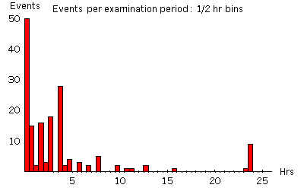
Figure: Number of examination periods falling in bins of ½ hour internals. There are 5 events longer that 24 hours (not shown).
Blocking
An examination period consists of an array of trial z-scores by indexed reg IDs and the time in seconds. The array is divided into data blocks according to the prediction specifications. Blockings used in the formal event analyses are shown in the figure below. A statistic is calculated for each data block (labelled “B” in the figure).
Blockings that include all reporting regs are termed network blocking (orange,cyan and blue in the figure).
Blockings that contain a only one reg are termed reg blocking (green).
The time dimension of a block is the blocking resolution. Thus, the orange blocking is “network blocking at one second”. About 75% of the events use this blocking scheme.
Blockings which take the whole examination period as a single block are event blockings and those containing a subset of regs are termed group blockings.

Time 
regs | z | z |  | z | z | z | z | z | B |  | z | z | z | z | z | z |  | z | z | z | z | z | z | z | z | z |  |  | z | z | z | z
regs | z | z |  | z | z | z | z | z | B |  | z | z | z | z | z | z |  | z | z | z | z | z | z | z | z | z |  |  | z | z | z | z
regs | z | z |  | z | z | z | z | z | B |  | z | z | z | z | z | z |  | z | z | z | z | z | z | z | z | z |  |  | z | z | z | z
regs | z | z |  | z | z | z | z | z | B |  | z | z | z | z | z | z |  | z | z | z | z | z | z | z | z | z |  |  | z | z | z | z
regs | z | z |  | z | z | z | z | z | B |  | z | z | z | z | z | z |  | z | z | z | z | z | z | z | z | z |  |  | z | z | z | z
regs | B | B |  |  |  |  |  |  |  |  |  | B |  |  |  |  |  |  |  | B |  |  |  |  |  |  |  |  | Var(z)

Recipes
The recipes stipulate how an event statistic is calculated. The recipe specifies (1) a block statistic within the blocked examination period and (2) an algorithm for calculating the event statistic. The 7 recipes are listed below. Some (rejected) events have undetermined or ambiguous recipes. These are grouped as recipe # 99. The Stouffer Z is the sum of N z-scores divided by Sqrt(N). The reg z-scores are the standardized trialsums.
1. Standard analysis
Blocking: network blocking at one second resolution
Block statistic: B = Stouffer Z of z-scores
Event statistic: Σ B² (treated as chisqr)
2. Reg blocking
Blocking: reg blocking at R-second resolution
Block statistic: B = Stouffer Z of z-scores
Event statistic: Σ B² (treated as chisqr)
3. New Years Meanshift
Blocking: network blocking at one second and 37 timezones
Block statistic: B = Stouffer Z of z-scores
Event statistic: Σ B² (treated as chisqr)
4. New Years Variance
Blocking: event blocking at 10-minutes and 37 timezones
Block statistic: B = Var(z)
Event statistic: - B (treated as chisqr)
5. Network blocking
Blocking: network blocking at R-seconds
Block statistic: B = Stouffer Z of z-scores
Event statistic: Σ B² (treated as chisqr)
6. Directed difference
Blocking: block all regs at one second resolution
Block statistic: B = Stouffer Z of z-scores
Event statistic: XXX (treated as chisqr)
7. Superposed periods
Blocking: all regs at one second resolution across T periods
Block statistic: B = Stouffer Z of z-scores
Event statistic: Σ B² (treated as chisqr)

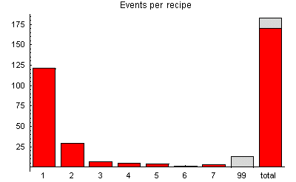
Figure: The distribution of events by recipe type.

Weighting

Analysis

